**pixel Based Image Encryption Using Magic Square**

**1. INTRODUCTION**

For secure transmission of data and information in internet, various cryptography techniques have been introduced. In Cryptography, the Sender will encipher the information in to unreadable format using key and the Receiver will decipher it using that sender’s key. It uses two types of key:

(i)Symmetric key –In Fig I(a) the sender and receiver will encrypt and decrypt the messages using the same key also known as secret key cryptography.

(ii) Asymmetric key – In Fig I(b) the sender and receiver uses a pair of key called private key and public key, they encipher and decipher the information using the keys respectively.

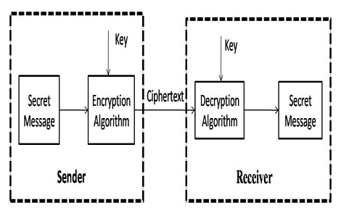

Fig I(a). Symmetric Key Cryptosystem

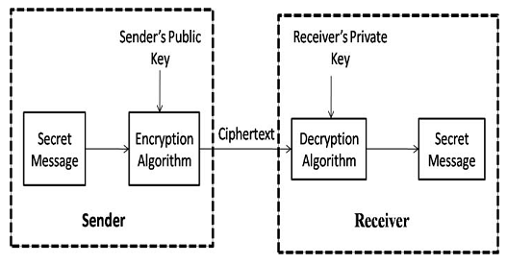

Fig I(b) Asymmetric key Cryptosystem

The Image is made up of pixels. The pixel is a 32 bit representation of Red (8bit), Green (8bit), Blue (8bit) and alpha values (8 bit). Image encryption is classified into

1. Value transformation of pixels

2. Visual transformation of pixels

3. Position Transformation of pixels

**Objective of the Project**

In recent world, the way of transferring the secured information particularly in public sectors, has faced more challenges. To minimize these challenges, cryptographic concepts has been introduced. Cryptography is the art of technique that is used to changing the information in to unreadable format based on the user’s key. Various cryptographic concepts have been introduced for text and image. Due to data redundancy and mass data capacity the text encryption methods are difficult to handle the image encryption. Image encryption is done by changing the position of the pixels in an image based on the key provided by the user. In the existing method, the image encryption is done by the magic rectangle method. It contains only one magic rectangle and if it is computed, the intruder can easily retrieve the original image. To overcome this, we proposed the Pan Magic Square encryption algorithm for the image to be encrypted. In PMS, the plain text image is partitioned into pixels. By user’s key, 64 magic squares are generated. Then, encrypt the image based on the square values. The image is being encrypted by the PMS algorithm. The encrypted image is transmitted to the receiver. The receiver will decrypt the image by the reverse process of the encryption. The encrypted image provided by the algorithm is different from the plaintext image so we can securely transmit over the internet. After decryption, the resulting image provided by the proposed technique will be same as the original plaintext image.

**2. LITERATURE SURVEY**

**Enhancing the Security in Cryptosystems Based on Magic Rectangle**

The security of any cryptosystems is based on the way in which it produces different ciphertext for the same plaintext. Normally, various block cipher modes viz., CBC, OFC, etc., are used in producing different ciphertext for the same plaintext but it is a time consuming process. Instead of using block cipher, a different encoding method for the plaintext is proposed in this paper using magic rectangle. The advantage of using the encoding scheme is different numerals is used in encoding each characters of a plaintext. Thus instead of considering the ASCII encoding for a character to be encrypted, the numeral which occurs at the position which corresponds to the ASCII value of the character is taken from the magic rectangle. Further, different numerals from magic rectangles for the same character are produced by considering the magic sum, starting number and template of magic rectangle. Once the magic rectangles are created, the numerals which occur in the magic rectangles are considered for the encoding of the plaintext character which is then used for encryption in the cryptosystems like RSA, ElGamal. The proposed work provides an additional layer of security to any public key cryptosystems. As this model is acting as a wrapper to any public key cryptosystems, it ensures enhanced security. The proposed methodology is implemented with different processors 1, 2, 4, 8 and 16 in a simulated environment using Maui scheduler which employs back filling philosophy.

An alternate encoding scheme based on MR instead of existing ASCII based encoding scheme has been thought of and the numerals involved in MR are used for encryption in RSA and ElGamal public-key cryptosystems. The numerals are not easily tracked by the eavesdropper because the magic sum, MRS and MRT used in generating the MR are only known to the sender and the receiver. Additionally, for the same magic sum different MRs is generated by interchanging rows or columns which will produce different numerals at the same position every time. This causes an additional layer of security for any cryptosystems before performing encryption and decryption. Further, to speedup cryptographic operations parallelism is used in this paper which is based on Maui scheduler in simulated environment with different processors. For RSA encryption and decryption without MR the speed is increased around 1.89 and 1.88 times respectively when the number of processors is increased. Then for RSA encryption and decryption with MR the speed is increased around 1.87 and 1.85 times respectively. For ElGamal encryption and decryption without MR the speed is increased around 1.92 and 1.89 times respectively. Then for ElGamal encryption and decryption with MR the speed is increased around 1.97 and 1.91 times respectively. Further, the security level of RSA and ElGamal without MR is 77.08 and 86.24 when RSA and ElGamal cryptosystems are incorporated in MR the security level is 88.02 and 94.12 respectively.

**Add-On Security Model for Public-Key Cryptosystem Based on Magic Square Implementation**

The efficiency of a cryptographic algorithm is based on its time taken for encryption / decryption and the way it produces different cipher text from a clear text. The RSA, the widely used public key algorithm and other public key algorithms may not guarantee that the cipher text is fully secured. As an alternative approach to handling ASCII characters in the cryptosystems, a magic square implementation is thought of in this work. It attempts to enhance the efficiency by providing add-on security to the cryptosystem. This approach will increase the security due to its complexity in encryption because it deals with the magic square formation with seed number, start number and sum that cannot be easily traced. Here, encryption / decryption are based on numerals generated by magic square rather than ASCII values. This proposed work provides another layer of security to any public key algorithms such as RSA, ElGamal etc., since, this model is acting as a wrapper to a public key algorithm, it ensures that the security is enhanced. Further, this approach is experimented in a simulated environment with 2, 4, 8, and 16 processor model using Maui scheduler which is based on back filling philosophy.

An alternative approach to existing ASCII based cryptosystem a number based approach is thought of and implemented. This methodology will add-on one more layer of security, it adds numerals for the text even before feeding into public-key algorithm for encryption. This add-on security is built using magic square position equivalent to the character to be encrypted.

**Design and Implementation of Image Encryption Algorithm by using Block Based Symmetric Transformation Algorithm (Hyper Image Encryption Algorithm)**

The primary goal of this paper is security management. This will provide authentication of users, and integrity, accuracy and safety of images which is traveling over internet. Moreover, an image-based data requires more effort during encryption and decryption. The Proposed Architecture for encryption and decryption of an image using suitable user defined key is developed with the same objective. In this paper, we introduce a new permutation technique based on the combination of image permutation and a new developed encryption algorithm called “Hyper Image Encryption Algorithm (HIEA)”. From the selected image we will binary value blocks, which will be rearrange into a permuted image using a permutation process, and then the generated image will be encrypted using the “Hyper Image Encryption Algorithm (HIEA)” algorithm.

The difference of efficiency between our “Proposed Algorithm” and “Image Encryption Using Block-Based Transformation Algorithm”, “An Image Encryption Approach Using a Combination of Permutation Technique Followed by Encryption” is very high approximately 80% . If the security and efficiency is of primary concern then one can use our proposed algorithm. From the above discussion we can clearly see that the proposed algorithm has 70% better entropy of encrypted image any of the other compeering algorithms and hence can be incorporated in the process of encryption of any images. Also, we can see that the “Image Encryption Using Block-Based Transformation Algorithm” and “An Image Encryption Approach Using a Combination of Permutation Technique Followed by Encryption” have very less entropy and hence cannot be used for encryption of confidential messages. The encryption algorithm presented above, is a very simple, direct mapping algorithm using feistal Structure and some logical operation. This cipher image generation provides a good strength to the encryption algorithm. As such it is quite essential to improve our algorithms performance in future.

**Image Encryption Using Block-Based Transformation Algorithm**

Encryption is used to securely transmit data in open networks. Each type of data has its own features; therefore different techniques should be used to protect confidential image data from unauthorized access. Most of the available encryption algorithms are mainly used for textual data and may not be suitable for multimedia data such as images. In this paper, we introduce a block-based transformation algorithm based on the combination of image transformation and a well known encryption and decryption algorithm called Blowfish. The original image was divided into blocks, which were rearranged into a transformed image using a transformation algorithm presented here, and then the transformed image was encrypted using the Blowfish algorithm. The results showed that the correlation between image elements was significantly decreased by using the proposed technique. The results also show that increasing the number of blocks by using smaller block sizes resulted in a lower correlation and higher entropy.

In this paper a simple and strong method has been proposed for image security using a combination of block based image transformation and encryption techniques. The cases showed that the correlation was decreased when the proposed algorithm was applied to them before the Blowfish algorithm. Experimental results of the proposed technique showed that an inverse relationship exists between number of blocks and correlation, and a direct relationship between number of blocks and entropy. When compared to many commonly used algorithms, the proposed algorithm resulted in the best performance; the lowest correlation and the highest entropy.

**Image Encryption based on the RGB PIXEL Transposition and Shuffling**

Privacy is one of the key issues information Security addresses. Through encryption one can prevent a third party from understanding raw data during signal transmission. The encryption methods for enhancing the security of digital contents has gained high significance in the current era of breach of security and misuse of the confidential information intercepted and misused by the unauthorized parties. This paper sets out to contribute to the general body of knowledge in the area of cryptography application and by developing a cipher algorithm for image encryption of m*n size by shuffling the RGB pixel values. The algorithm ultimately makes it possible for encryption and decryption of the images based on the RGB pixel. The algorithm was implemented using MATLAB.

The transposition and reshuffling of the RGB values of the image in steps has proven to be really effective in terms of the security analysis. The extra swapping of RGB values in the image file after RGB component shifting has increased the security of the image against all possible attacks available currently.

**Pixel Indicator Technique for RGB Image Steganography**

Image based steganography utilize the images as cover media to hide secret data. The common technique used in this field replaces the least significant bits (LSB) of image pixels with intended secret bits. Several improvements to enhance the security of the LSB method have been presented earlier. This paper proposed a new improved technique that takes the advantage of the 24 bits in each pixel in the RGB images using the two least significant bits of one channel to indicate existence of data in the other two channels. The stego method does not depend on a separate key to take out the key management overhead. Instead, it is using the size of the secret data as selection criteria for the first indicator channel to insert security randomness. Our proposed technique is analyzed using security and capacity measures and compared to two other similar work. This proposed pixel indicator technique for RGB image steganography showed interesting promising result.

The multi-bit Image steganography has many techniques to hide data. We have proposed a new pixel indicator technique (PIT) for RGB image based steganography. The PIT novelty is that it uses one channel for indication of secret data in the other channels. This indication channel changes from pixel to another with natural random value depending on the image pixels.

**RGB Intensity Based Variable-Bits Image Steganography**

In this paper, we present a new algorithm for RGB image based steganography. Our algorithm introduces the concept of storing variable number of bits in each channel (R, G or B) of pixel based on the actual color values of that pixel: lower color component stores higher number of bits. Our algorithm offers very high capacity for cover media compared to other existing algorithms. We present experimental results showing the superiority of our algorithm. We also present comparative results with other similar algorithms in image based steganography.

In this paper, we introduce a new idea in image based steganography, where variable no bits can be stored in each channel. Our algorithm uses actual color of the channel to decide no of data bits to store. This approach leads to very high capacity with low visual distortions. Experimental results demonstrate that our algorithm performs better than other similar algorithms.

**Fast Image Encryption based on Random Image Key**

Internet plays an important role in circulating a huge amount of multimedia. An example of this multimedia is the image. To send an image over the network secretly, the sender tries to find encryption algorithm to hide image information. This paper aims at designing an efficient encryption algorithm for color image using random image key generated with minimum time execution for encryption and decryption operations. XOR operation is used here to make more diffusion of the encrypted image to maintain a higher level of security upon transference than it is with the original image.

The color image encryption and decryption algorithm is proposed and implemented depend on fast image key. Image key can generate from the same image or any image must the same size of origin color image. The sender and receiver shared the same image key which has the same properties of hash function therefore, the attacker cannot discover the plain image from the image key notably, if one pixel value is changed, different key will generated. Proposed algorithm give a good results through applied some statistical tests as well the proposed algorithm achieved encryption rate about 0.134136 and 0.106204 for decryption rate. Finally, it is possible to encrypt partial image instead of full image encryption. Also it can be applied as a block cipher instead of stream cipher to get good results. As well as it can be developed by compression of the plain image with image key to reduce the cost of data transition.

**3. ANALYSIS**

**Introduction**

The Systems Development Life Cycle (SDLC), or Software Development Life Cycle in [systems engineering](http://en.wikipedia.org/wiki/Systems_engineering" \o "Systems engineering), [information systems](http://en.wikipedia.org/wiki/Information_systems" \o "Information systems) and [software engineering](http://en.wikipedia.org/wiki/Software_engineering" \o "Software engineering), is the process of creating or altering systems, and the models and [methodologies](http://en.wikipedia.org/wiki/Methodologies" \o "Methodologies) that people use to develop these systems. In software engineering the SDLC concept underpins many kinds of [software development methodologies](http://en.wikipedia.org/wiki/Software_development_methodologies" \o "Software development methodologies). These methodologies form the framework for planning and controlling the creation of an information system the [software development process](http://en.wikipedia.org/wiki/Software_development_process" \o "Software development process).

**Existing System**

Various cryptographic concepts have been introduced for text and image. Due to data redundancy and mass data capacity the text encryption methods are difficult to handle the image encryption. Image encryption is done by changing the position of the pixels in an image based on the key provided by the user. In the existing method, the image encryption is done by the magic rectangle method. It contains only one magic rectangle and if it is computed, the intruder can easily retrieve the original image.

**Proposed System**

We proposed the Pan Magic Square encryption algorithm for the image to be encrypted. In PMS, the plain text image is partitioned into pixels. By user’s key, 64 magic squares are generated. Then, encrypt the image based on the square values. The image is being encrypted by the PMS algorithm. The encrypted image is transmitted to the receiver. The receiver will decrypt the image by the reverse process of the encryption. The encrypted image provided by the algorithm is different from the plaintext image so we can securely transmit over the internet. After decryption, the resulting image provided by the proposed technique will be same as the original plain text image

**3.1. PROCESS MODEL USED WITH JUSTIFICATION**

**SDLC (Umbrella Model):**

**Umbrella Activity**

**Umbrella Activity**

**Umbrella Activity**

1. Feasibility Study
2. TEAM FORMATION
3. Project Specification PREPARATION

Business Requirement Documentation

ANALYSIS & DESIGN

CODE

UNIT TEST

DOCUMENT CONTROL

ASSESSMENT

TRAINING

INTEGRATION & SYSTEM TESTING

DELIVERY/INSTALLATION

ACCEPTANCE TEST

Requirements Gathering

SDLC is nothing but Software Development Life Cycle. It is a standard which is used by software industry to develop good software.

**Stages in SDLC:**

* Requirement Gathering
* Analysis
* Designing
* Coding
* Testing
* Maintenance

**Requirements Gathering** **stage:**

The requirements gathering process takes as its input the goals identified in the high-level requirements section of the project plan. Each goal will be refined into a set of one or more requirements. These requirements define the major functions of the intended application, define operational data areas and reference data areas, and define the initial data entities. Major functions include critical processes to be managed, as well as mission critical inputs, outputs and reports. A user class hierarchy is developed and associated with these major functions, data areas, and data entities. Each of these definitions is termed a Requirement. Requirements are identified by unique requirement identifiers and, at minimum, contain a requirement title and textual description.

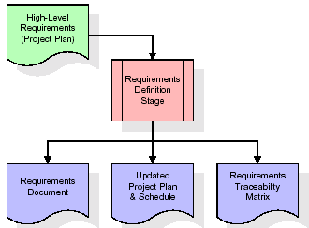

These requirements are fully described in the primary deliverables for this stage: the Requirements Document and the Requirements Traceability Matrix (RTM). The requirements document contains complete descriptions of each requirement, including diagrams and references to external documents as necessary. Note that detailed listings of database tables and fields are *not* included in the requirements document.

The title of each requirement is also placed into the first version of the RTM, along with the title of each goal from the project plan. The purpose of the RTM is to show that the product components developed during each stage of the software development lifecycle are formally connected to the components developed in prior stages.

In the requirements stage, the RTM consists of a list of high-level requirements, or goals, by title, with a listing of associated requirements for each goal, listed by requirement title. In this hierarchical listing, the RTM shows that each requirement developed during this stage is formally linked to a specific product goal. In this format, each requirement can be traced to a specific product goal, hence the term *requirements traceability*.

The outputs of the requirements definition stage include the requirements document, the RTM, and an updated project plan.

* Feasibility study is all about identification of problems in a project.
* No. of staff required to handle a project is represented as Team Formation, in this case only modules are individual tasks will be assigned to employees who are working for that project.
* Project Specifications are all about representing of various possible inputs submitting to the server and corresponding outputs along with reports maintained by administrator.

**Analysis Stage:**

The planning stage establishes a bird's eye view of the intended software product, and uses this to establish the basic project structure, evaluate feasibility and risks associated with the project, and describe appropriate management and technical approaches.

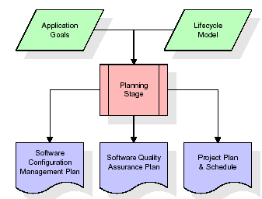

The most critical section of the project plan is a listing of high-level product requirements, also referred to as goals. All of the software product requirements to be developed during the requirements definition stage flow from one or more of these goals. The minimum information for each goal consists of a title and textual description, although additional information and references to external documents may be included. The outputs of the project planning stage are the configuration management plan, the quality assurance plan, and the project plan and schedule, with a detailed listing of scheduled activities for the upcoming Requirements stage, and high level estimates of effort for the out stages.

**Designing Stage:**

The design stage takes as its initial input the requirements identified in the approved requirements document. For each requirement, a set of one or more design elements will be produced as a result of interviews, workshops, and/or prototype efforts. Design elements describe the desired software features in detail, and generally include functional hierarchy diagrams, screen layout diagrams, tables of business rules, business process diagrams, pseudo code, and a complete entity-relationship diagram with a full data dictionary. These design elements are intended to describe the software in sufficient detail that skilled programmers may develop the software with minimal additional input.

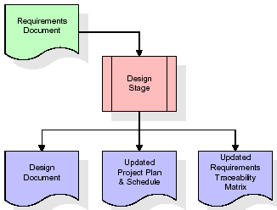  
When the design document is finalized and accepted, the RTM is updated to show that each design element is formally associated with a specific requirement. The outputs of the design stage are the design document, an updated RTM, and an updated project plan.

**Development (Coding) Stage:**

The development stage takes as its primary input the design elements described in the approved design document. For each design element, a set of one or more software artifacts will be produced. Software artifacts include but are not limited to menus, dialogs, data management forms, data reporting formats, and specialized procedures and functions. Appropriate test cases will be developed for each set of functionally related software artifacts, and an online help system will be developed to guide users in their interactions with the software.

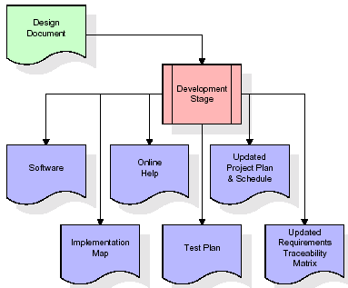

The RTM will be updated to show that each developed artifact is linked to a specific design element, and that each developed artifact has one or more corresponding test case items. At this point, the RTM is in its final configuration. The outputs of the development stage include a fully functional set of software that satisfies the requirements and design elements previously documented, an online help system that describes the operation of the software, an implementation map that identifies the primary code entry points for all major system functions, a test plan that describes the test cases to be used to validate the correctness and completeness of the software, an updated RTM, and an updated project plan.

**Integration & Test Stage:**

During the integration and test stage, the software artifacts, online help, and test data are migrated from the development environment to a separate test environment. At this point, all test cases are run to verify the correctness and completeness of the software. Successful execution of the test suite confirms a robust and complete migration capability. During this stage, reference data is finalized for production use and production users are identified and linked to their appropriate roles. The final reference data (or links to reference data source files) and production user list are compiled into the Production Initiation Plan.

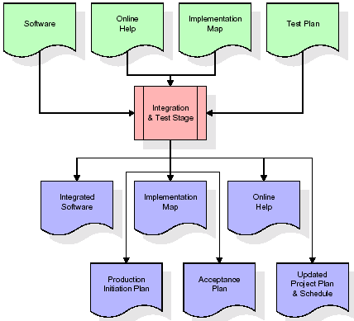

The outputs of the integration and test stage include an integrated set of software, an online help system, an implementation map, a production initiation plan that describes reference data and production users, an acceptance plan which contains the final suite of test cases, and an updated project plan.

* **Installation & Acceptance Test:**

During the installation and acceptance stage, the software artifacts, online help, and initial production data are loaded onto the production server. At this point, all test cases are run to verify the correctness and completeness of the software. Successful execution of the test suite is a prerequisite to acceptance of the software by the customer.

After customer personnel have verified that the initial production data load is correct and the test suite has been executed with satisfactory results, the customer formally accepts the delivery of the software.

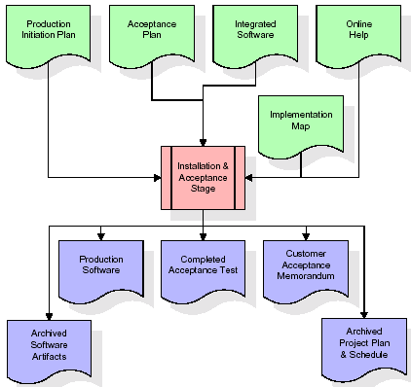

The primary outputs of the installation and acceptance stage include a production application, a completed acceptance test suite, and a memorandum of customer acceptance of the software. Finally, the PDR enters the last of the actual labor data into the project schedule and locks the project as a permanent project record. At this point the PDR "locks" the project by archiving all software items, the implementation map, the source code, and the documentation for future reference.

**Maintenance:**

Outer rectangle represents maintenance of a project, Maintenance team will start with requirement study, understanding of documentation later employees will be assigned work and they will undergo training on that particular assigned category. For this life cycle there is no end, it will be continued so on like an umbrella (no ending point to umbrella sticks).

**3.2. Software Requirement Specification**

**3.2.1. Overall Description**

A Software Requirements Specification (SRS) – a [requirements specification](http://en.wikipedia.org/wiki/Requirements_specification" \o "Requirements specification) for a [software system](http://en.wikipedia.org/wiki/Software_system" \o "Software system) is a complete description of the behavior of a system to be developed. It includes a set of [use cases](http://en.wikipedia.org/wiki/Use_case" \o "Use case) that describe all the interactions the users will have with the software. In addition to use cases, the SRS also contains non-functional requirements. [Nonfunctional requirements](http://en.wikipedia.org/wiki/Non-functional_requirements" \o "Non-functional requirements) are requirements which impose constraints on the design or implementation (such as [performance engineering](http://en.wikipedia.org/wiki/Performance_engineering" \o "Performance engineering) requirements, [quality](http://en.wikipedia.org/wiki/Quality_%28business%29" \o "Quality (business)) standards, or design constraints).

System requirements specification: A structured collection of information that embodies the requirements of a system. A [business analyst](http://en.wikipedia.org/wiki/Business_analyst" \o "Business analyst), sometimes titled [system analyst](http://en.wikipedia.org/wiki/System_analyst" \o "System analyst), is responsible for analyzing the business needs of their clients and stakeholders to help identify business problems and propose solutions. Within the [systems development lifecycle](http://en.wikipedia.org/wiki/Systems_development_life_cycle" \o "Systems development life cycle) domain, the BA typically performs a liaison function between the business side of an enterprise and the information technology department or external service providers. Projects are subject to three sorts of requirements:

* [Business requirements](http://en.wikipedia.org/wiki/Business_requirements" \o "Business requirements) describe in business terms *what* must be delivered or accomplished to provide value.
* Product requirements describe properties of a system or product (which could be one of several ways to accomplish a set of business requirements.)
* Process requirements describe activities performed by the developing organization. For instance, process requirements could specify .Preliminary investigation examine project feasibility, the likelihood the system will be useful to the organization. The main objective of the feasibility study is to test the Technical, Operational and Economical feasibility for adding new modules and debugging old running system. All system is feasible if they are unlimited resources and infinite time. There are aspects in the feasibility study portion of the preliminary investigation:
* **ECONOMIC FEASIBILITY**

A system can be developed technically and that will be used if installed must still be a good investment for the organization. In the economical feasibility, the development cost in creating the system is evaluated against the ultimate benefit derived from the new systems. Financial benefits must equal or exceed the costs. The system is economically feasible. It does not require any addition hardware or software. Since the interface for this system is developed using the existing resources and technologies available at NIC, There is nominal expenditure and economical feasibility for certain.

* **Operational Feasibility**

Proposed projects are beneficial only if they can be turned out into information system. That will meet the organization’s operating requirements. Operational feasibility aspects of the project are to be taken as an important part of the project implementation. This system is targeted to be in accordance with the above-mentioned issues. Beforehand, the management issues and user requirements have been taken into consideration. So there is no question of resistance from the users that can undermine the possible application benefits. The well-planned design would ensure the optimal utilization of the computer resources and would help in the improvement of performance status.

* **TECHNICAL FEASIBILITY**

Earlier no system existed to cater to the needs of ‘Secure Infrastructure Implementation System’. The current system developed is technically feasible. It is a web based user interface for audit workflow at NIC-CSD. Thus it provides an easy access to .the users. The database’s purpose is to create, establish and maintain a workflow among various entities in order to facilitate all concerned users in their various capacities or roles. Permission to the users would be granted based on the roles specified. Therefore, it provides the technical guarantee of accuracy, reliability and security.

**3.2.2. External Interface Requirements**

**User Interface**

The user interface of this system is a user friendly Java Graphical User Interface.

**Hardware Interfaces**

The interaction between the user and the console is achieved through Java capabilities.

**Software Interfaces**

The required software is JAVA1.6.

**Operating Environment**

Windows XP, Linux.

**HARDWARE REQUIREMENTS:**

# Processor - Pentium –IV

* Speed - 1.1 Ghz
* RAM - 256 MB(min)
* Hard Disk - 20 GB
* Key Board - Standard Windows Keyboard
* Mouse - Two or Three Button Mouse
* Monitor - SVGA

**SOFTWARE REQUIREMENTS:**

* Operating System : Windows XP
* Programming Language : Java

**4. DESIGN**

**UML diagrams**

The Unified Modeling Language allows the software engineer to express an analysis model using the modeling notation that is governed by a set of syntactic semantic and pragmatic rules.

A UML system is represented using five different views that describe the system from distinctly different perspective. Each view is defined by a set of diagram, which is as follows.

* + **User Model View**
    1. This view represents the system from the users perspective.
    2. The analysis representation describes a usage scenario from the end-users perspective.
  + **Structural Model view**
    1. In this model the data and functionality are arrived from inside the system.
    2. This model view models the static structures.
* **Behavioral Model View**

It represents the dynamic of behavioral as parts of the system, depicting the interactions of collection between various structural elements described in the user model and structural model view.

* **Implementation Model View**

In this the structural and behavioral as parts of the system are represented as they are to be built.

* **Environmental Model View**

In this the structural and behavioral aspects of the environment in which the system is to be implemented are represented.

**4.1 Class diagram:-**

The class diagram is the main building block of object oriented modeling. It is used both for general conceptual modeling of the systematic of the application, and for detailed modeling translating the models into programming code. Class diagrams can also be used for data modeling. The classes in a class diagram represent both the main objects, interactions in the application and the classes to be programmed. A class with three sections, in the diagram, classes is represented with boxes which contain three parts:

* The upper part holds the name of the class
* The middle part contains the attributes of the class
* The bottom part gives the methods or operations the class can take or undertake

**Class diagram:**



**4.2 Use case diagram:-**

A **use case diagram** at its simplest is a representation of a user's interaction with the system and depicting the specifications of a use case. A use case diagram can portray the different types of users of a system and the various ways that they interact with the system. This type of diagram is typically used in conjunction with the textual use case and will often be accompanied by other types of diagrams as well.

**4.2.1 Use case diagram:**



**4.3. Sequence Diagram:**

A **sequence diagram** is a kind of interaction diagram that shows how processes operate with one another and in what order. It is a construct of a Message Sequence Chart. A sequence diagram shows object interactions arranged in time sequence. It depicts the objects and classes involved in the scenario and the sequence of messages exchanged between the objects needed to carry out the functionality of the scenario. Sequence diagrams are typically associated with use case realizations in the Logical View of the system under development. Sequence diagrams are sometimes called **event diagrams**, **event scenarios**, and timing diagrams.

**4.3.1 Sequence diagram:**



**4.4 Collaboration diagram**

A collaboration diagram describes interactions among objects in terms of sequenced messages. Collaboration diagrams represent a combination of information taken from class, sequence, and use case diagrams describing both the static structure and dynamic behavior of a system.

**4.5.1 Collaboration diagram:**



**4.6 Component Diagram**

In the Unified Modeling Language, a component diagram depicts how components are wired together to form larger components and or software systems. They are used to illustrate the structure of arbitrarily complex systems

Components are wired together by using an assembly connector to connect the required interface of one component with the provided interface of another component. This illustrates the service consumer - service provider relationship between the two components.

**4.6.1 Component diagram:**



**4.7 Deployment Diagram**

A **deployment diagram** in the Unified Modeling Language models the *physical* deployment of artifacts on nodes. To describe a web site, for example, a deployment diagram would show what hardware components ("nodes") exist (e.g., a web server, an application server, and a database server), what software components ("artifacts") run on each node (e.g., web application, database), and how the different pieces are connected (e.g. JDBC, REST, RMI).

The nodes appear as boxes, and the artifacts allocated to each node appear as rectangles within the boxes. Nodes may have sub nodes, which appear as nested boxes. A single node in a deployment diagram may conceptually represent multiple physical nodes, such as a cluster of database servers.

**4.7.1 Deployment diagram:**



**4.8 Activity diagram:**

Activity diagram is another important diagram in UML to describe dynamic aspects of the system. It is basically a flow chart to represent the flow form one activity to another activity. The activity can be described as an operation of the system.

So the control flow is drawn from one operation to another. This flow can be sequential, branched or concurrent.

**4.8.1 Activity diagram:**

Upload Image

Yes

Verify the images are available or not?

NO

There is no process

Generate Square

Encrypt Image

Map Square & Decrypt Image

Exit

**4.9 Data Flow Diagram:**

[Data flow diagrams](http://www.edrawsoft.com/Data-Flow-Diagrams.php) illustrate how data is processed by a system in terms of inputs and outputs. Data flow diagrams can be used to provide a clear representation of any business function. The technique starts with an overall picture of the business and continues by analyzing each of the functional areas of interest. This analysis can be carried out in precisely the level of detail required. The technique exploits a method called top-down expansion to conduct the analysis in a targeted way.

As the name suggests, Data Flow Diagram (DFD) is an illustration that explicates the passage of information in a process. A DFD can be easily drawn using simple symbols. Additionally, complicated processes can be easily automated by creating DFDs using easy-to-use, free downloadable diagramming tools. A DFD is a model for constructing and analyzing information processes. DFD illustrates the flow of information in a process depending upon the inputs and outputs. A DFD can also be referred to as a Process Model. A DFD demonstrates business or technical process with the support of the outside data saved, plus the data flowing from the process to another and the end results.

**Data Flow Diagram:**

User

1. Upload Image 10. Exit from the screen
2. Generate Square 8. Image decrypt & save in decrypt file
3. Encrypt Image 6. Image encrypt & save in encrypt file
4. Map Square & Decrypt Image 4. Magic square from A & B generated
5. Exit 2. Image loaded

System

**5. IMPLEMENTATION**

**Modules**

1. Generation of tables
2. Encryption
3. Decryption

**Module Description:**

**Generation of tables**

Create a table for 8! =40320 combinations. For 128 bits key size, generate 64 tables by taking two bits for each square. The first row of the table is taken from one of the combinations of 8! Based on the key given by user.

**Encryption**

Each pixel is a unification of Red, Green and Blue values. RGB values are represented by 8 bits. After generating 64 squares, the red value in the first pixel is converted into binary form, first four bits represents the row and second four bits represent the column of the first magic square. After mapping the row and column values, the value in the square is replaced by the red value.

In 2nd pixel - Green value is replaced by the second magic square

In 3rd pixel - Blue value is replaced by the third magic square

It is done for all pixel in the image respectively. For 65th pixel, it replaces with the first magic square. Thus, the image is being encrypted by the Magic Square.

**Decryption**

From the key, the receiver will generate the square. In encrypted image, the red value in first pixel is searched in first magic square then the corresponding value is replaced with the red pixel. The same process is done for rest of the pixels in the image. Thus the image is decrypted

**5.1. Introduction of technologies used**

**About Java**:

Initially the language was called as “oak” but it was renamed as “java” in 1995.The primary motivation of this language was the need for a platform-independent (i.e. architecture neutral) language that could be used to create software to be embedded in various consumer electronic devices.

* Java is a programmer’s language
* Java is cohesive and consistent
* Except for those constraint imposed by the Internet environment. Java gives the programmer, full control

Finally Java is to Internet Programming where c was to System Programming.

**Importance of Java to the Internet**

Java has had a profound effect on the Internet. This is because; java expands the Universe of objects that can move about freely in Cyberspace. In a network, two categories of objects are transmitted between the server and the personal computer. They are passive information and Dynamic active programs. in the areas of Security and probability. But Java addresses these concerns and by doing so, has opened the door to an exciting new form of program called the Applet.

**Applications and applets**

An application is a program that runs on our Computer under the operating system of that computer. It is more or less like one creating using C or C++ .Java’s ability to create Applets makes it important. An Applet I san application, designed to be transmitted over the Internet and executed by a Java-compatible web browser. An applet I actually a tiny Java program, dynamically downloaded across the network, just like an image. But the difference is, it is an intelligent program, not just a media file. It can be react to the user input and dynamically change.

**Java Architecture**

Java architecture provides a portable, robust, high performing environment for development. Java provides portability by compiling the byte codes for the Java Virtual Machine, which is then interpreted on each platform by the run-time environment. Java is a dynamic system, able to load code when needed from a machine in the same room or across the planet.

**Compilation of code**

When you compile the code, the Java compiler creates machine code (called byte code)for a hypothetical machine called Java Virtual Machine(JVM). The JVM is supposed t executed the byte code. The JVM is created for the overcoming the issue of probability. The code is written and compiled for one machine and interpreted on all machines .This machine is called Java Virtual Machine.

**Compiling and interpreting java source code.**



During run-time the Java interpreter tricks the byte code file into thinking that it is running on a Java Virtual Machine. In reality this could be an Intel Pentium windows 95 or sun SPARCstation running Solaris or Apple Macintosh running system and all could receive code from any computer through internet and run the Applets.

**Simple**:

Java was designed to be easy for the Professional programmer to learn and to use effectively. If you are an experienced C++ Programmer, learning Java will oriented features of C++. Most of the confusing concepts from C++ are either left out of Java or implemented in a cleaner, more approachable manner. In Java there are a small number of clearly defined ways to accomplish a given task.

### Object oriented

Java was not designed to be source-code compatible with any other language. This allowed the Java team the freedom to design with a blank state. One outcome of this was a clean usable, pragmatic approach to objects. The object model in Java is simple and easy to extend, while simple types, such as integers, are kept as high-performance non-objects.

### Robust

The multi-platform environment of the web places extraordinary demands on a program, because the program must execute reliably in a variety of systems. The ability to create robust programs was given a high priority in the design of Java? Java is strictly typed language; it checks your code at compile time and runtime.

Java virtually eliminates the problems of memory management and deal location, which is completely automatic. In a well-written Java program, all run-time errors can and should be managed by your program.

**AWT and Swings:**

**AWT:**

**Graphical User Interface:**

The user interface is that part of a program that interacts with the user of the program. GUI is a type of [user interface](http://en.wikipedia.org/wiki/User_interface" \o "User interface) that allows [users](http://en.wikipedia.org/wiki/User_(computing)" \o "User (computing)) to [interact](http://en.wikipedia.org/wiki/Human-computer_interaction" \o "Human-computer interaction) with electronic devices with images rather than text commands. A class library is provided by the Java programming language which is known as Abstract Window Toolkit (AWT) for writing graphical programs. The Abstract Window Toolkit (AWT) contains several graphical widgets which can be added and positioned to the display area with a layout manager.

As the Java programming language, the AWT is not platform-independent. AWT uses system peers object for constructing graphical widgets. A common set of tools is provided by the AWT for graphical user interface design. The implementation of the user interface elements provided by the AWT is done using every platform's native GUI toolkit. One of the AWT's significance is that the look and feel of each platform can be preserved.

**Components:**

A graphical user interface is built of graphical elements called components. A *component* is an object having a graphical representation that can be displayed on the screen and that can interact with the user. Components allow the user to interact with the program and provide the input to the program. In the AWT, all user interface components are instances of class Component or one of its subtypes. Typical components include such items as buttons, scrollbars, and text fields.

**Types of Components:**

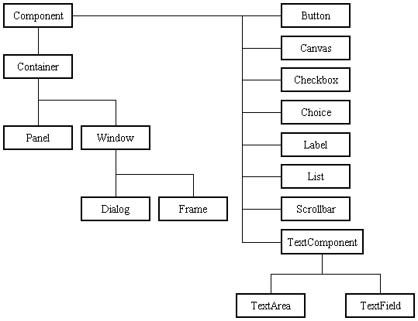

Before proceeding ahead, first we need to know what containers are. After learning containers we learn all components in detail.

**Containers:**

Components do not stand alone, but rather are found within containers. In order to make components visible, we need to add all components to the container. Containers contain and control the layout of components. In the AWT, all containers are instances of class Container or one of its subtypes. Components must fit completely within the container that contains them. For adding components to the container we will use add() method.

**Types of containers:**

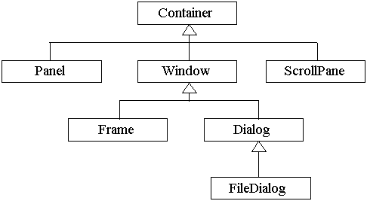

**Basic GUI Logic:**

The GUI application or applet is created in three steps. These are:

* Add components to Container objects to make your GUI.
* Then you need to setup event handlers for the user interaction with GUI.
* Explicitly display the GUI for application.

A new thread is started by the interpreter for user interaction when an AWT GUI is displayed. When any event is received by this new thread such as click of a mouse, pressing of key etc then one of the event handlers is called by the new thread set up for GUI. One important point to note here is that the event handler code is executed within the thread.

**Creating a Frame:**

**Method1:**

In the first method we will be creating frame by extending Frame class which is defined in java.awt package. Following program demonstrate the creation of a frame.

import java.awt.*;

public class FrameDemo1 extends Frame

{

FrameDemo1()

{

setTitle("Label Frame");

setVisible(true);

setSize(500,500);

}

public static void main(String[] args)

{

new FrameDemo1 ();

}

}

In the above program we are using three methods:

setTitle: For setting the title of the frame we will use this method. It takes String as an argument which will be the title name.

SetVisible: For making our frame visible we will use this method. This method takes Boolean value as an argument. If we are passing true then window will be visible otherwise window will not be visible.

SetSize: For setting the size of the window we will use this method. The first argument is width of the frame and second argument is height of the frame.

**Method 2:**

In this method we will be creating the Frame class instance for creating frame window. Following program demonstrate Method2.

import java.awt.*;

public class FrameDemo2

{

public static void main(String[] args)

{

Frame f = new Frame();

f.setTitle("My first frame");

f.setVisible(true);

f.setSize(500,500);

}

}

**Types of Components:**

1. **Labels :**

This is the simplest component of Java Abstract Window Toolkit. This component is generally used to show the text or string in your application and label never perform any type of action.

Label l1 = new Label("One");

Label l2 = new Label("Two");

Label l3 = new Label("Three",Label.CENTER);

In the above three lines we have created three labels with the name “one, two, three”. In the third label we are passing two arguments. Second argument is the justification of the label. Now after creating components we will be adding it to the container.

add(l1);

add(l2);

add(l3);

We can set or change the text in a label by using the **setText( )** method. You can obtain the current label by calling **getText( )**. These methods are shown here:

void setText(String *str*)

String getText( )

1. **Buttons :**

This is the component of Java Abstract Window Toolkit and is used to trigger actions and other events required for your application. The syntax of defining the button is as follows :

Button l1 = new Button("One");

Button l2 = new Button("Two");

Button l3 = new Button("Three");

We can change the Button's label or get the label's text by using the Button.setLabel(String) and Button.getLabel() method.

1. **CheckBox:**

A *check box is a control that is used to turn an option on or off. It consists of a small box* that can either contain a check mark or not. There is a label associated with each check box that describes what option the box represents. You change the state of a check box by clicking on it. The syntax of the definition of Checkbox is as follows :

Checkbox Win98 = new Checkbox("Windows 98/XP", null, true);

Checkbox winNT = new Checkbox("Windows NT/2000");

Checkbox solaris = new Checkbox("Solaris");

Checkbox mac = new Checkbox("MacOS");

The first form creates a check box whose label is specified in first argument and whose group is specified in second argument*.* If this check box is not part of a group, then *cbGroup* must be **null**. (Check box groups are described in the next section.) The value truedetermines the initial state of the check box is checked. The second form creates a check box with only one parameter.

To retrieve the current state of a check box, call **getState( )**. To set its state, call **setState( )**. You can obtain the current label associated with a check box by calling **getLabel( )**. To set the label, call **setLabel( )**. These methods are as follows:

boolean getState( )

void setState(boolean *on*)

String getLabel( )

void setLabel(String *str*)

Here, if *on* is **true**, the box is checked. If it is **false**, the box is cleared. The string passed in *str* becomes the new label associated with the invoking check box.

1. **Radio Button:**

This is the special case of the Checkbox component of Java AWT package. This is used as a group of checkboxes which group name is same. Only one Checkbox from a Checkbox Group can be selected at a time. Syntax for creating radio buttons is as follows:

CheckboxGroup cbg = new CheckboxGroup();

Checkbox Win98 = new Checkbox("Windows 98/XP", cbg , true);

Checkbox winNT = new Checkbox("Windows NT/2000",cbg, false);

Checkbox solaris = new Checkbox("Solaris",cbg, false);

Checkbox mac = new Checkbox("MacOS",cbg, false);

For Radio Button we will be using CheckBox class. The only difference in Checkboxes and radio button is in Check boxes we will specify null for checkboxgroup but whereas in radio button we will be specifiying the checkboxgroup object in the second parameter.

1. **Choice:**

The Choice class is used to create a pop-up list of items from which the user may choose. Thus, a Choice control is a form of menu. Syntax for creating choice is as follows:

Choice os = new Choice();

/* adding items to choice */

os.add("Windows 98/XP");

os.add("Windows NT/2000");

os.add("Solaris");

os.add("MacOS");

We will be creating choice with the help of Choice class. Pop up list will be creating with the creation of object, but it will not have any items. For adding items we will be using add() method defined in Choice class.

To determine which item is currently selected, you may call either **getSelectedItem( )** or **getSelectedIndex( )**. These methods are shown here:

String getSelectedItem( )

int getSelectedIndex( )

The **getSelectedItem( )** method returns a string containing the name of the item. **getSelectedIndex( )** returns the index of the item. The first item is at index 0. By default, the first item added to the list is selected.

1. **List:**

List class is also same as choice but the only difference in list and choice is, in choice user can select only one item whereas in List user can select more than one item. Syntax for creating list is as follows:

List os = new List(4, true);

First argument in the List constructor specifies the number of items allowed in the list. Second argument specifies whether multiple selections are allowed or not.

/* Adding items to the list */

os.add("Windows 98/XP");

os.add("Windows NT/2000");

os.add("Solaris");

os.add("MacOS");

In list we can retrieve the items which are selected by the users. In multiple selection user will be selecting multiple values for retrieving all the values we have a method called getSelectedValues() whose return type is string array. For retrieving single value again we can use the method defined in Choice i.e. getSelectedItem().

1. **TextField:**

Text fields allow the user to enter strings and to edit the text using the arrow keys, cut and paste keys. TextField is a subclass of TextComponent. Syntax for creating list is as follows:

TextField tf1 = new TextField(25);

TextField tf2 = new TextField();

In the first text field we are specifying the size of the text field and the second text field is created with the default value. **TextField** (and its superclass **TextComponent**) provides several methods that allow you to utilize a text field. To obtain the string currently contained in the text field, call **getText( )**. To set the text, call **setText( )**. These methods are as follows:

String getText( )

void setText(String *str*)

We can control whether the contents of a text field may be modified by the user by calling **setEditable( )**. You can determine editability by calling **isEditable( )**. These methods are shown here:

boolean isEditable( )

void setEditable(boolean *canEdit*)

**isEditable( )** returns **true** if the text may be changed and **false** if not. In **setEditable( )**, if *canEdit* is **true**, the text may be changed. If it is **false**, the text cannot be altered.

There may be times when we will want the user to enter text that is not displayed, such as a password. We can disable the echoing of the characters as they are typed by calling **setEchoChar( )**.

1. **TextArea:**

TextArea is a multiple line editor. Syntax for creating list is as follows:

TextArea area = new TextArea(20,30);

Above code will create one text area with 20 rows and 30 columns. **TextArea** is a subclass of **TextComponent**. Therefore, it supports the **getText( )**, **setText( )**, **getSelectedText( )**, **select( )**, **isEditable( )**, and **setEditable( )** methods described in the preceding section.

**TextArea** adds the following methods:

void append(String *str*)

void insert(String *str*, int *index*)

void replaceRange(String *str*, int *startIndex*, int *endIndex*)

The **append( )** method appends the string specified by *str* to the end of the current text. **insert( )** inserts the string passed in *str* at the specified index. To replace text, call **replaceRange( )**. It replaces the characters from *startIndex* to *endIndex*–1, with the replacement text passed in *str.*

**Layout Managers:**

A layout manager automatically arranges controls within a window by using some type of algorithm. Each **Container** object has a layout manager associated with it. A layout manager is an instance of any class that implements the **LayoutManager** interface. The layout manager is set by the **setLayout( )** method. If no call to **setLayout( )** is made, then the default layout manager is used. Whenever a container is resized (or sized for the first time), the layout manager is used to position each of the components within it. The **setLayout( )** method has the following general form:

void setLayout(LayoutManager *layoutObj*)

Here, *layoutObj* is a reference to the desired layout manager. If you wish to disable the layout manager and position components manually, pass **null** for *layoutObj.* If we do this, you will need to determine the shape and position of each component manually, using the setBounds( ) method defined by Component.

Void setBounds(int x , int y , int width, int length)

In which first two arguments are the x and y axis. Third argument is width and fourth argument is height of the component.

Java has several predefined **LayoutManager** classes, several of which are described next. You can use the layout manager that best fits your application.

**FlowLayout:**

**FlowLayout** is the default layout manager. This is the layout manager that the preceding examples have used. **FlowLayout** implements a simple layout style, which is similar to how words flow in a text editor. Components are laid out from the upper-left corner, left to right and top to bottom. When no more components fit on a line, the next one appears on the next line. A small space is left between each component, above and below, as well as left and right. Here are the constructors for **FlowLayout**:

FlowLayout( )

FlowLayout(int *how*)

FlowLayout(int *how*, int *horz*, int *vert*)

The first form creates the default layout, which centers components and leaves five pixels of space between each component. The second form lets you specify how each line is aligned. Valid values for *how* are as follows:

FlowLayout.LEFT

FlowLayout.CENTER

FlowLayout.RIGHT

These values specify left, center, and right alignment, respectively. The third form allows you to specify the horizontal and vertical space left between components in *horz* and *vert,* respectively.

**BorderLayout:**

THE JAVA LIBRARYThe **BorderLayout** class implements a common layout style for top-level windows. It has four narrow, fixed-width components at the edges and one large area in the center. The four sides are referred to as north, south, east, and west. The middle area is called the center. Here are the constructors defined by **BorderLayout**:

BorderLayout( )

BorderLayout(int *horz*, int *vert*)

The first form creates a default border layout. The second allows you to specify the horizontal and vertical space left between components in *horz* and *vert,* respectively. **BorderLayout** defines the following constants that specify the regions:

BorderLayout.CENTER BorderLayout.SOUTH

BorderLayout.EAST BorderLayout.WEST

BorderLayout.NORTH

When adding components, you will use these constants with the following form of **add( )**, which is defined by **Container**:

void add(Component *compObj,* Object *region*);

Here, *compObj* is the component to be added, and *region* specifies where the component will be added.

**GridLayout:**

**GridLayout** lays out components in a two-dimensional grid. When you instantiate a **GridLayout**, you define the number of rows and columns. The constructors supported by **GridLayout** are shown here:

GridLayout( )

GridLayout(int *numRows*, int *numColumns* )

GridLayout(int *numRows*, int *numColumns*, int *horz*, int *vert*)

The first form creates a single-column grid layout. The second form creates a grid layout with the specified number of rows and columns. The third form allows you to specify the horizontal and vertical space left between components in *horz* and *vert*, respectively. Either *numRows* or *numColumns* can be zero. Specifying *numRows* as zero allows for unlimited-length columns. Specifying *numColumns* as zero allows for unlimited-length rows.

**Swings:**

**About Swings:**

Swing is important to develop Java programs with a graphical user interface (GUI). There are many components which are used for the building of GUI in Swing. The Swing Toolkit consists of many components for the building of GUI. These components are also helpful in providing interactivity to Java applications. Following are components which are included in Swing toolkit:

* list controls
* buttons
* labels
* tree controls
* table controls

All AWT flexible components can be handled by the Java Swing. Swing toolkit contains far more components than the simple component toolkit. It is unique to any other toolkit in the way that it supports integrated internationalization, a highly customizable text package, rich undo support etc. Not only this you can also create your own look and feel using Swing other than the ones that are supported by it. The customized look and feel can be created using Synth which is specially designed. Not to forget that Swing also contains the basic user interface such as customizable painting, event handling, drag and drop etc.

The Java Foundation Classes (JFC) which supports many more features important to a GUI program comprises of Swing as well. The features which are supported by Java Foundation Classes (JFC) are the ability to create a program that can work in different languages, the ability to add rich graphics functionality etc.

There are several components contained in Swing toolkit such as check boxes, buttons, tables, text etc. Some very simple components also provide sophisticated functionality. For instance, text fields provide formatted text input or password field behavior. Furthermore, the file browsers and dialogs can be used according to one's need and can even be customized.

**Difference between Swings and AWT:**

|  |  |
| --- | --- |
| **Swings** | **AWT** |
| Swings are the light weight components. | AWTs are the heavy weight components. |
| Swings are developed by using pure java language. | AWTs are developed by using C and C++. |
| We can have different look and feel in swings. | This feature is not available in awt. |
| Swing has many advanced features like JTabel, JTabbedPane and JTree | This is not available in AWT. |

**Java Swing Class Hierarchy:**

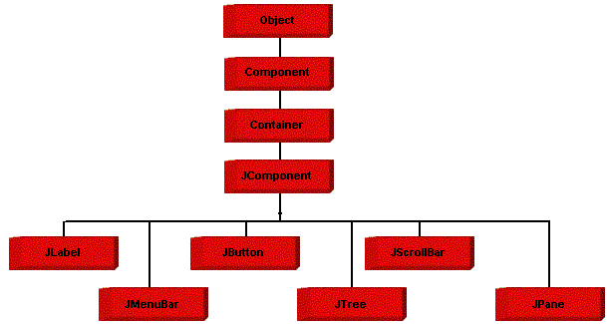

**Swing Components:**

All the components which are supported in AWT same components are also supported in Swings with a slight change in their class name.

|  |  |
| --- | --- |
| **AWT Components** | **Swing Components** |
| Label | JLabel |
| TextField | JTextField |
| TextArea | JTextArea |
| Choice | JComboBox |
| Checkbox | JCheckBox |
| List | JList |
| Button | JButton |
| - | JRadioButton |
| - | JPasswordField |
| - | JTable |
| - | JTree |
| - | JTabbedPane |
| MenuBar | JMenuBar |
| Menu | JMenu |
| MenuItem | JMenuItem |
| - | JFileChooser |
| - | JOptionPane |

We will discuss only those components which are not discussed in AWT chapter.

**JTabbedPane class:**

 The JTabbedPane container allows many panels to occupy the same area of the interface, and the user may select which to show by clicking on a tab.

**Constructor**

JTabbedPane tp = new JTabbedPane();

## Adding tabs to the JTabbedPane

Add tabs to a tabbed pane by calling addTab and passing it a String title and an instance of a class which should be called when we pressed a tab. That class should be a subclass of JPanel.

addTab(“String”,instance);

**Example program:**

import javax.swing.*;

import java.awt.*;

public class TabbedPaneDemo extends JFrame

{

TabbedPaneDemo()

{

setLayout(new FlowLayout(FlowLayout.LEFT));

setTitle("Tabbed Demo");

setVisible(true);

setSize(500,500);

setDefaultCloseOperation(JFrame.EXIT_ON_CLOSE);

JTabbedPane pane = new JTabbedPane();

pane.addTab("Countries",new Count());

pane.addTab("Cities",new Cit());

add(pane);

}

public static void main(String a[])

{

new TabbedPaneDemo();

}

}

class Count extends JPanel

{

Count()

{

JButton b1 = new JButton("India");

JButton b2 = new JButton("SriLanka");

JButton b3 = new JButton("Australia");

add(b1);

add(b2);

add(b3);

}

}

class Cit extends JPanel

{

Cit()

{

JCheckBox cb1 = new JCheckBox("Hyderabad");

JCheckBox cb2 = new JCheckBox("Banglore");

JCheckBox cb3 = new JCheckBox("Pune");

add(cb1);

add(cb2);

add(cb3);

}

}

**JMenuBar, JMenu, JMenuItem**

A top-level window can have a menu bar associated with it. A menu bar displays a list of top-level menu choices. Each choice is associated with a drop-down menu. This concept is implemented in Java by the following classes: JMenuBar, JMenu, and JMenuItem. In general, a menu bar contains one or more JMenu objects. Each JMenu object contains a list of JMenuItem objects. Each JMenuItem object represents something that can be selected by the user. To create a menu bar, first create an instance of JMenuBar. This class only defines the default constructor. Next, create instances of JMenu that will define the selections displayed on the bar. Following are the constructors for Menu:

JMenu( )

JMenu(String *optionName*)

Here, *optionName* specifies the name of the menu selection. The first form creates an empty menu. Individual menu items are of type MenuItem. It defines these constructors:

JMenuItem( )

JMenuItem(String *itemName*)

Here, *itemName* is the name shown in the menu.

**5.5 Sample Code**

**Main.java**

package com;

import java.awt.BorderLayout;

import java.awt.Color;

import java.awt.Container;

import java.awt.Font;

import javax.swing.JFrame;

import javax.swing.JLabel;

import javax.swing.JPanel;

import javax.swing.JButton;

import javax.swing.SwingUtilities;

import java.awt.event.ActionListener;

import java.awt.event.ActionEvent;

import javax.swing.JOptionPane;

import javax.swing.UIManager;

import java.io.File;

import javax.swing.JFileChooser;

import javax.swing.ImageIcon;

import java.awt.Dimension;

import java.awt.image.BufferedImage;

import javax.imageio.ImageIO;

public class Main extends JFrame{

JPanel p1,p2,p3;

JLabel l1,l2;

Font f1,f2;

JButton b1,b2,b3,b4,b5;

JFileChooser chooser;

File file;

public Main(){

setTitle("Pixel Based Image Encryption");

f1 = new Font("Times New Roman",Font.BOLD,16);

p1 = new JPanel();

l1 = new JLabel("<html><body><center><br/>Pixel Based Image Encryption Using Magic Square".toUpperCase());

l1.setFont(this.f1);

l1.setForeground(Color.white);

p1.add(l1);

p1.setBackground(new Color(204, 110, 155));

f2 = new Font("Times New Roman", 1, 14);

chooser = new JFileChooser(new File("images"));

p3 = new JPanel();

b1 = new JButton("Upload Image");

b1.setFont(f2);

p3.add(b1);

b1.addActionListener(new ActionListener(){

public void actionPerformed(ActionEvent ae){

int option = chooser.showOpenDialog(Main.this);

if(option == chooser.APPROVE_OPTION){

file = chooser.getSelectedFile();

String name = file.getName().toLowerCase();

if(name.endsWith("jpg") || name.endsWith("gif") || name.endsWith("png")){

ImageIcon icon = new ImageIcon(file.getPath());

icon.getImage().flush();

l2.setIcon(icon);

JOptionPane.showMessageDialog(Main.this,"Image loaded");

}else{

JOptionPane.showMessageDialog(Main.this,"Only jpg,gif and png are allowed");

}

}

}

});

b2 = new JButton("Generate Square");

b2.setFont(f2);

p3.add(b2);

b2.addActionListener(new ActionListener(){

public void actionPerformed(ActionEvent ae){

Square.readSquare();

ViewSquare vs = new ViewSquare();

for(int i=0;i<Square.cols;i++){

vs.dtm.addColumn(i+"");

}

Object head1[] = {"Matrix A"};

vs.dtm.addRow(head1);

for(int i=0;i<Square.A.length;i++){

Object row[] = new Object[Square.cols];

for(int j=0;j<Square.A[i].length;j++){

row[j] = Square.A[i][j];

}

vs.dtm.addRow(row);

}

Object head2[] = {"Matrix B"};

vs.dtm.addRow(head2);

for(int i=0;i<Square.B.length;i++){

Object row[] = new Object[Square.cols];

for(int j=0;j<Square.B[i].length;j++){

row[j] = Square.B[i][j];

}

vs.dtm.addRow(row);

}

Object head3[] = {"Square Matrix"};

vs.dtm.addRow(head3);

for(int i=0;i<Square.square.length;i++){

Object row[] = new Object[Square.cols];

for(int j=0;j<Square.square[i].length;j++){

row[j] = Square.square[i][j];

}

vs.dtm.addRow(row);

}

vs.setVisible(true);

vs.setSize(600,400);

}

});

b3 = new JButton("Encrypt Image");

b3.setFont(f2);

p3.add(b3);

b3.addActionListener(new ActionListener(){

public void actionPerformed(ActionEvent ae){

try{

Square.encrypt(file);

JOptionPane.showMessageDialog(Main.this,"Image Encrypted & save in encrypt file");

}catch(Exception e){

e.printStackTrace();

}

}

});

b4 = new JButton("Map Square & Decrypt Image");

b4.setFont(f2);

p3.add(b4);

b4.addActionListener(new ActionListener(){

public void actionPerformed(ActionEvent ae){

try{

Square.decrypt();

JOptionPane.showMessageDialog(Main.this,"Image Decrypted & save in decrypt file");

}catch(Exception e){

e.printStackTrace();

}

}

});

b5 = new JButton("Exit");

b5.setFont(f2);

p3.add(b5);

b5.addActionListener(new ActionListener(){

public void actionPerformed(ActionEvent ae){

System.exit(0);

}

});

p2 = new JPanel();

l2 = new JLabel(new ImageIcon("images/Sunset.jpg"));

p2.add(l2);

p2.setPreferredSize(new Dimension(800,600));

getContentPane().add(p1, "North");

getContentPane().add(p3, "Center");

getContentPane().add(p2, "South");

}

public static void main(String a[])throws Exception {

UIManager.setLookAndFeel(UIManager.getSystemLookAndFeelClassName());

Main cs = new Main();

cs.setVisible(true);

cs.setExtendedState(JFrame.MAXIMIZED_BOTH);

}

}

**Square.java**

package com;

import java.io.BufferedReader;

import java.io.FileReader;

import java.util.ArrayList;

import java.awt.image.BufferedImage;

import javax.imageio.ImageIO;

import java.io.File;

import java.awt.Color;

public class Square{

static int A[][];

static int B[][];

static int square[][];

static ArrayList<String> data = new ArrayList<String>();

static int cols;

public static void readSquare(){

try{

BufferedReader br = new BufferedReader(new FileReader("square.txt"));

String line = null;

while((line = br.readLine()) != null){

line = line.trim();

if(line.length() > 0){

data.add(line);

}

}

br.close();

String arr[] = data.get(0).split("\\s+");

cols = arr.length;

int rows = data.size();

A = new int[rows][cols];

B = new int[rows][cols];

square = new int[rows][cols];

for(int i=0;i<data.size();i++){

String array[] = data.get(i).split("\\s+");

for(int j=0;j<array.length;j++){

A[i][j] = Integer.parseInt(array[j]);

}

}

int end = cols-1;

int start = (cols/2) - 1 ;

boolean flag = false;

for(int i=0;i<A.length;i++){

for(int j=0;j<A[i].length;j+=2){

if(i == 0){

B[i][j] = A[i][end];

B[i][j+1] = A[i][start];

} if(i == 1) {

B[i][j] = A[i][start];

B[i][j+1] = A[i][end];

}

if(!flag && i > 1 && (i % 2) == 0){

B[i][j] = A[i][end];

B[i][j+1] = A[i][start];

}

if(!flag && i > 1 && (i % 2) == 1){

B[i][j] = A[i][start];

B[i][j+1] = A[i][end];

}

if(flag && i > 1 && (i % 2) == 0){

B[i][j] = A[i][start];

B[i][j+1] = A[i][end];

}

if(flag && i > 1 && (i % 2) == 1){

B[i][j] = A[i][end];

B[i][j+1] = A[i][start];

}

}

end = end - 1;

start = start - 1;

if(start == -1){

start = (cols/2) - 1;

end = cols - 1;

flag = true;

}

}

int n = 4 ;

for(int i=0;i<B.length;i++){

for(int j=0;j<B[i].length;j++){

int value = A[i][j] + n * B[i][j] - n;

//value = A[i][j] ^ value;

square[i][j] = value;

}

}

for(int i=0;i<square.length;i++){

for(int j=0;j<square[i].length;j++){

System.out.print(square[i][j]+" ");

}

System.out.println();

}

}catch(Exception e){

e.printStackTrace();

}

}

public static void encrypt(File file)throws Exception{

BufferedImage bi=ImageIO.read(file);

BufferedImage image= new BufferedImage(bi.getWidth(),bi.getHeight(),BufferedImage.TYPE_INT_ARGB);

for(int x=0;x<bi.getWidth();x++){

for(int y=0;y<bi.getHeight();y++){

Color c = new Color(bi.getRGB(x, y));

int red = c.getRed();

int green = c.getGreen();

int blue = c.getBlue();

String redc[] = getBinary(red);

String greenc[] = getBinary(green);

String bluec[] = getBinary(blue);

int p1 = square[Integer.parseInt(redc[0],2)][Integer.parseInt(redc[1],2)];

int p2 = square[Integer.parseInt(greenc[0],2)][Integer.parseInt(greenc[1],2)];

int p3 = square[Integer.parseInt(bluec[0],2)][Integer.parseInt(bluec[1],2)];

square[Integer.parseInt(redc[0],2)][Integer.parseInt(redc[1],2)] = red;

square[Integer.parseInt(greenc[0],2)][Integer.parseInt(greenc[1],2)] = green;

square[Integer.parseInt(bluec[0],2)][Integer.parseInt(bluec[1],2)] = blue;

image.setRGB(x,y,new Color(p1,p2,0).getRGB());

}

}

File outputfile = new File("encrypt.jpg");

ImageIO.write(image, "jpg", outputfile);

}

public static void decrypt()throws Exception{

BufferedImage bi=ImageIO.read(new File("encrypt.jpg"));

BufferedImage image= new BufferedImage(bi.getWidth(),bi.getHeight(),BufferedImage.TYPE_INT_RGB);

for(int x=0;x<bi.getWidth();x++){

for(int y=0;y<bi.getHeight();y++){

Color c = new Color(bi.getRGB(x, y));

int red = c.getRed();

int green = c.getGreen();

int blue = c.getBlue();

String redc[] = getBinary(red);

String greenc[] = getBinary(green);

String bluec[] = getBinary(blue);

int p1 = square[Integer.parseInt(redc[0],2)][Integer.parseInt(redc[1],2)];

int p2 = square[Integer.parseInt(greenc[0],2)][Integer.parseInt(greenc[1],2)];

int p3 = square[Integer.parseInt(bluec[0],2)][Integer.parseInt(bluec[1],2)];

image.setRGB(x,y,new Color(p1,p2,p3).getRGB());

}

}

File outputfile = new File("decrypt.jpg");

ImageIO.write(image, "jpg", outputfile);

}

public static String[] getBinary(int value){

String binary = Integer.toBinaryString(value);

StringBuilder sb = new StringBuilder();

int length = 8 - binary.length();

for(int j=0;j<length;j++){

sb.append("0");

}

sb.append(binary);

String arr[] = new String[2];

binary = sb.toString();

arr[0] = binary.substring(0,4);

arr[1] = binary.substring(4,binary.length());

return arr;

}

}

**6. TESTING**

**Implementation and Testing:**

Implementation is one of the most important tasks in project is the phase in which one has to be cautions because all the efforts undertaken during the project will be very interactive. Implementation is the most crucial stage in achieving successful system and giving the users confidence that the new system is workable and effective. Each program is tested individually at the time of development using the sample data and has verified that these programs link together in the way specified in the program specification. The computer system and its environment are tested to the satisfaction of the user.

## Implementation

## The implementation phase is less creative than system design. It is primarily concerned with user training, and file conversion. The system may be requiring extensive user training. The initial parameters of the system should be modifies as a result of a programming. A simple operating procedure is provided so that the user can understand the different functions clearly and quickly. The different reports can be obtained either on the inkjet or dot matrix printer, which is available at the disposal of the user. The proposed system is very easy to implement. In general implementation is used to mean the process of converting a new or revised system design into an operational one.

## Testing

Testing is the process where the test data is prepared and is used for testing the modules individually and later the validation given for the fields. Then the system testing takes place which makes sure that all components of the system property functions as a unit. The test data should be chosen such that it passed through all possible condition. Actually testing is the state of implementation which aimed at ensuring that the system works accurately and efficiently before the actual operation commence. The following is the description of the testing strategies, which were carried out during the testing period.

### System Testing

Testing has become an integral part of any system or project especially in the field of information technology. The importance of testing is a method of justifying, if one is ready to move further, be it to be check if one is capable to with stand the rigors of a particular situation cannot be underplayed and that is why testing before development is so critical. When the software is developed before it is given to user to user the software must be tested whether it is solving the purpose for which it is developed. This testing involves various types through which one can ensure the software is reliable. The program was tested logically and pattern of execution of the program for a set of data are repeated. Thus the code was exhaustively checked for all possible correct data and the outcomes were also checked.

**Module Testing**

To locate errors, each module is tested individually. This enables us to detect error and correct it without affecting any other modules. Whenever the program is not satisfying the required function, it must be corrected to get the required result. Thus all the modules are individually tested from bottom up starting with the smallest and lowest modules and proceeding to the next level. Each module in the system is tested separately. For example the job classification module is tested separately. This module is tested with different job and its approximate execution time and the result of the test is compared with the results that are prepared manually. The comparison shows that the results proposed system works efficiently than the existing system. Each module in the system is tested separately. In this system the resource classification and job scheduling modules are tested separately and their corresponding results are obtained which reduces the process waiting time.

**Integration Testing**

After the module testing, the integration testing is applied. When linking the modules there may be chance for errors to occur, these errors are corrected by using this testing. In this system all modules are connected and tested. The testing results are very correct. Thus the mapping of jobs with resources is done correctly by the system.

**Acceptance Testing**

When that user fined no major problems with its accuracy, the system passers through a final acceptance test. This test confirms that the system needs the original goals, objectives and requirements established during analysis without actual execution which elimination wastage of time and money acceptance tests on the shoulders of users and management, it is finally acceptable and ready for the operation.

**Test Cases**

|  |  |  |  |  |  |  |  |
| --- | --- | --- | --- | --- | --- | --- | --- |
| **Test Case Id** | **Test Case Name** | **Test Case Desc.** | **Test Steps** | | | **Test Case Status** | **Test Priority** |
| **Step** | **Expected** | **Actual** |
| 01 | Upload Image | Verify the image is uploaded or not | If it’s not uploaded | There is no process | Image loaded | High | High |
| 02 | Generate Matrix | Verify the image is loaded or not | If it’s not loaded | We cannot generate the matrix | Magic square generated for A & B | High | High |
| 03 | Encrypt Image | Verify the image is loaded or not | If it’s not loaded | We cannot encrypt the image | Image encrypted & save in encrypt file | High | High |
| 04 | Map Square & Decrypt Image | Verify the image is loaded or not | If it’s not loaded | We cannot decrypt the image | Image decrypted & save in decrypt file | High | High |
| 05 | Exit | Verify all the operations completed or not | If it’s not completed | We cannot exit | Exit from the screen | High | High |

**7. SCREEN SHOTS**

In this project author is describing concept to encrypt or decrypt image using its pixel value and magic square, magic square will be constructed using 16X16 matrix whose images are given in base paper with matrix A and matrix B, both matrix will be computed to form magic square using below formula.

A + 4n×B - 4n

In above formula A refers to matrix A and B refers to matrix B and n is the key

Matrix square A example



Just fill this matrix first row from 1 to 8 and 16 to 9, rest rows will be reverse of its previous rows. Square B will be constructed by taking last column and mid column of each row. Below is matrix B example



In matrix B we can see last value of Matrix A from first row become first row of matrix B and will continue till end and later both this matrix will compute to generate square magic matrix.

To encrypt image we will read image pixel value (RGB value) which consist of three integer digits and then convert each digit into 8 bits binary, first four bit will be use as row index of magic square and next four bit will be use as column index of magic square, whatever value located at that magic square row and column will be replace with image pixel value, due to replacement image data will be change and get encrypted. To decrypt image user will perform reverse operation and the image will be decrypted.

Note: in code folder square.txt file contains matrix A data. Algorithm code written inside ‘Square.java’ file

**Screen shots**

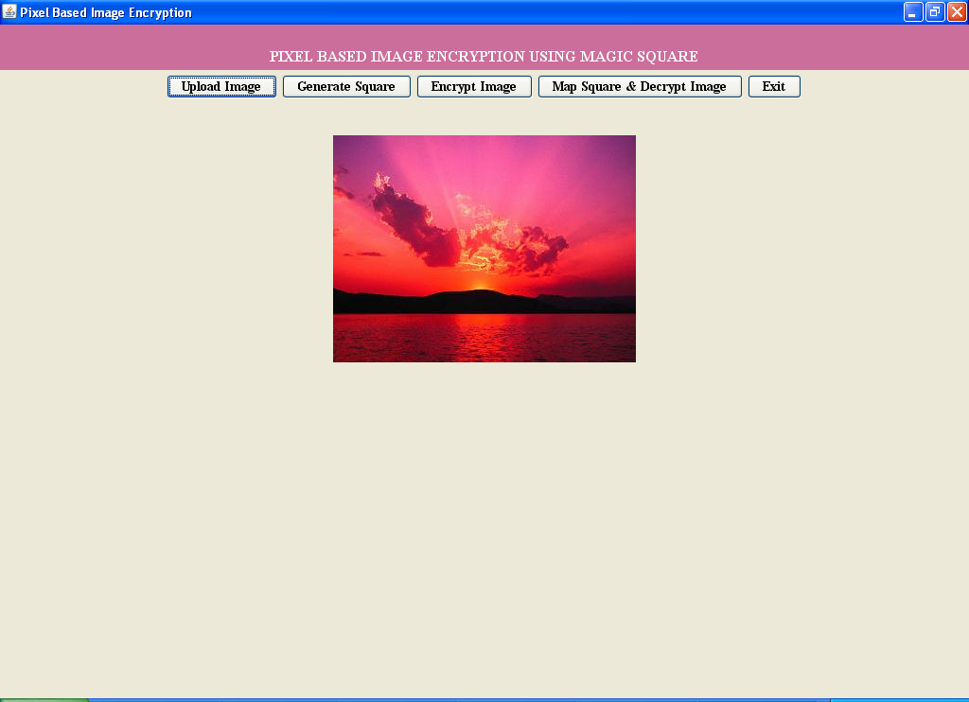

Now click on ‘Upload Image’ button and load image

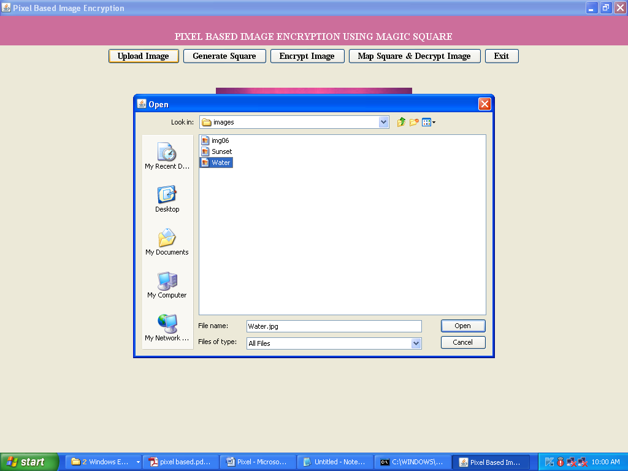

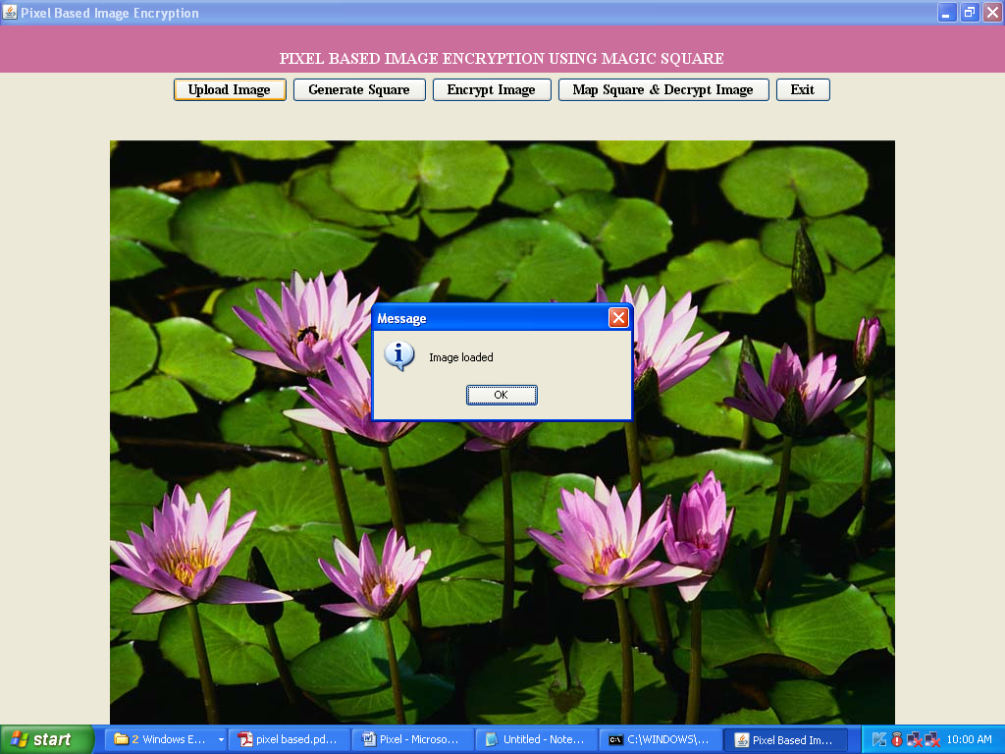

Now click on ‘Generate Square’ button to construct magic square and to get below screen

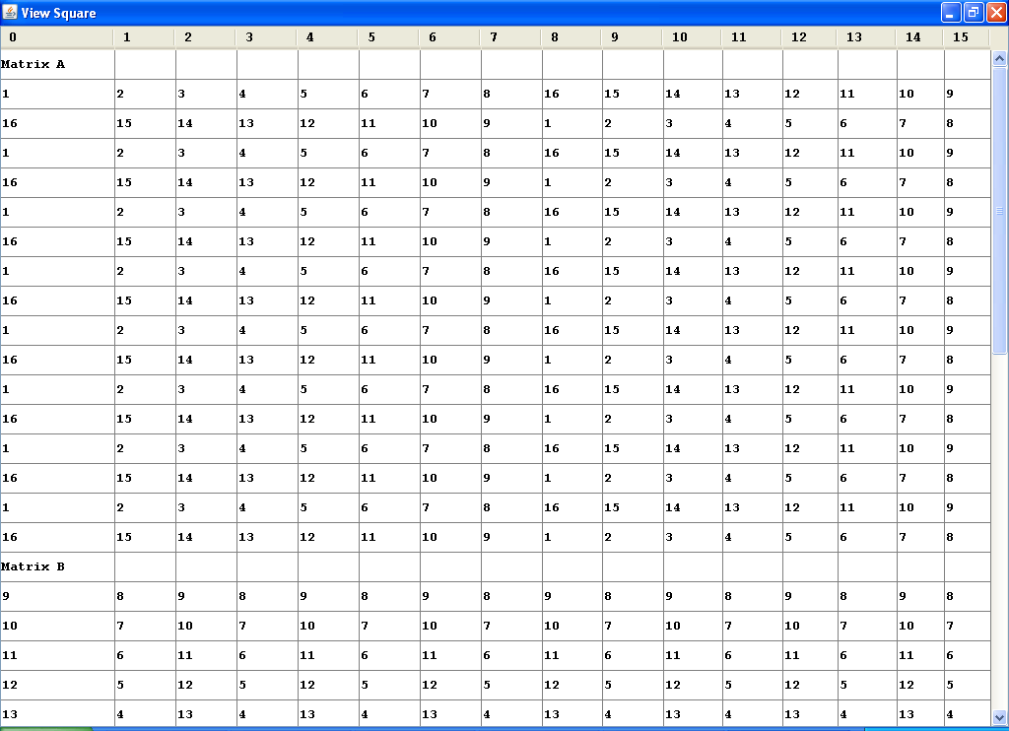

In above screen we can see Matrix A and B value and in below screen we can see computed Magic Square from A and B

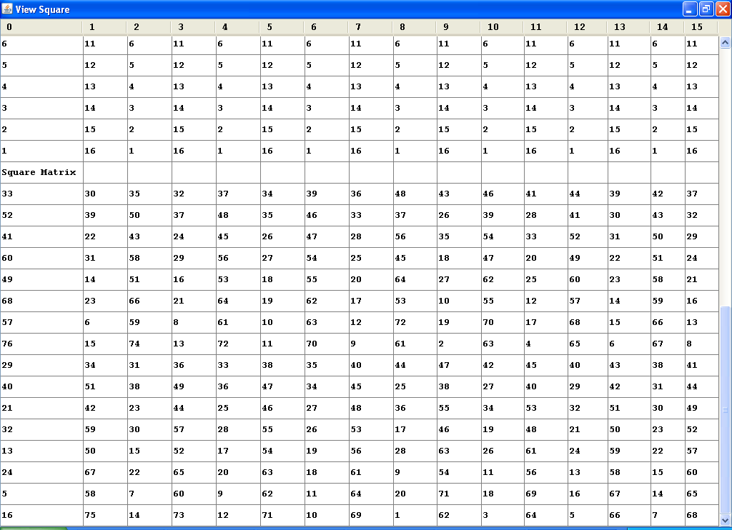

Now click on ‘Encrypt image’ button to encrypt image

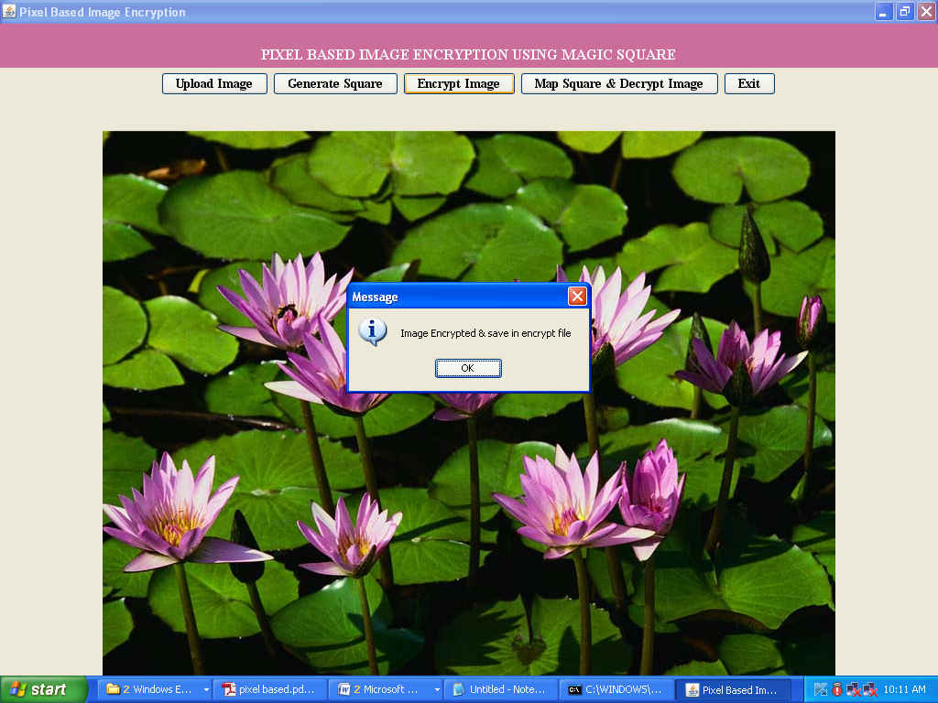

After encrypting image we can get new image with name encrypt.jpg which contains encrypt image data. Now click on ‘encrypt.jpg’ file inside code folder to get below image

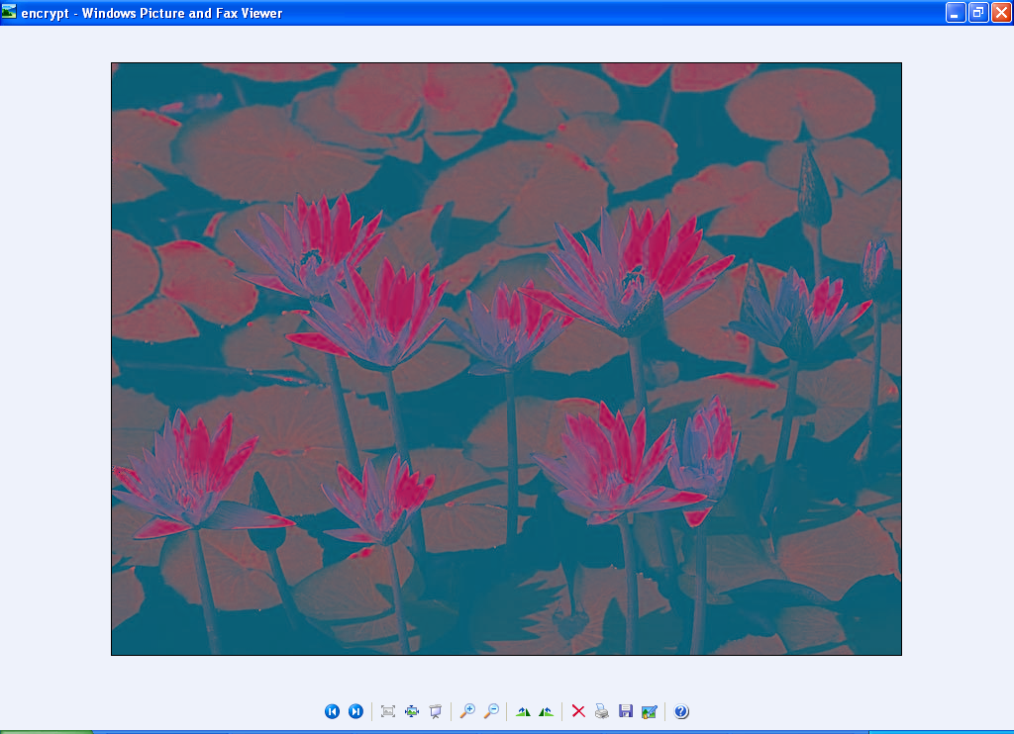

To decrypt image click on ‘Map Square & Decrypt Image’ button to decrypt image

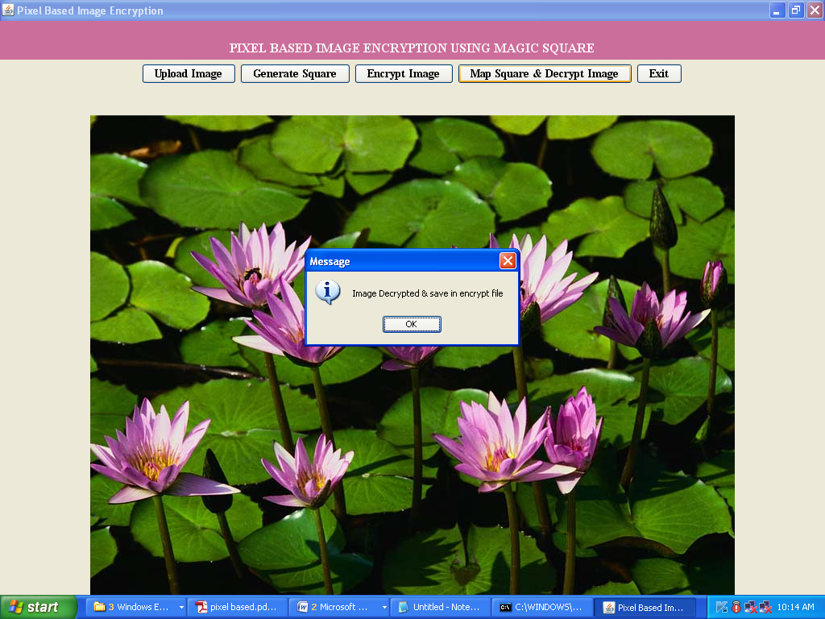

Once again new image will be created with name ‘decrypt.jpg’ name, double click on decrypt.jpg file inside code folder to get below screen

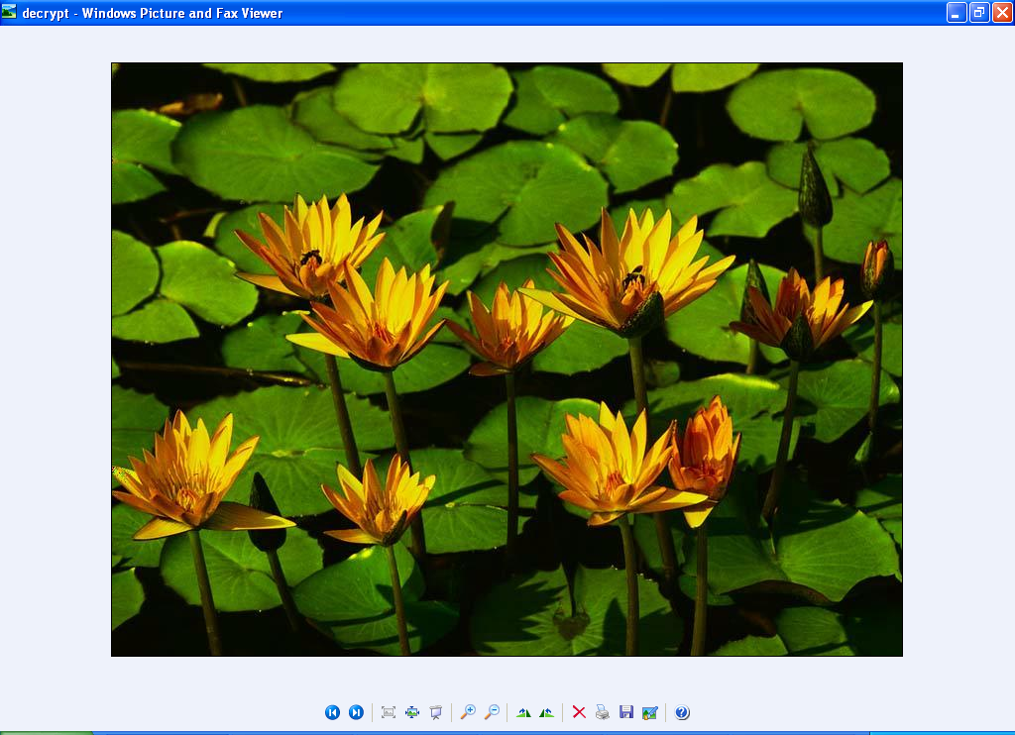

**8. CONCLUSION**

The different methods are discussed so far for sending and receiving information in secured manner by using various techniques of cryptography concept. This proposed work introduces the image encryption technique and provides the additional level of security to the image by changing the RGB values of each pixel in an image. Even though, the time and space complexity increases, the original image can be obtained only after computing 64 squares. It makes the algorithm work more efficient and hard to detect the original image.

**9. BIBLIOGRAPHY**

[1] D.I.George Amalarethinam, J.Sai geetha, ,” Enhancing Security Level for Public Key Cryptosystem Using MRGA”, World Congress on Computing and Communication Technologies (WCCCT),2014 Pages 98- 102.ISBN:978-1- 4799-2876-7.

[2] Gopinath Ganapathy, and K.Mani , “ Add-On Security Model for public key Cryptosystem Based on Magic Square Implementation”, ISBN 978-988- 17012-6-8, Proceedings of the world congress on Engineering and Computer Science 2009 Vol I, San Fransisco, USA.

[3] Hiral Rathod, Mahendra Singh Sisodia, Sanjay Kumar Sharma,” Design and Implementation of Image Encryption Algorithm by using Block Based Symmetric Transformation Algorithm (Hyper image Encryption Algorithm)”, International Journal of Computer Technology and Electronics Engineering (IJCTEE) Volume 1, Issue 3, ISSN 2249-6343

[4] Mohammad Ali Bani Younes and Aman Jantan, “Image Encryption Using Block-Based Transformation Algorithm”, IAENG International Journal of Computer Science, 35:1, IJCS_35_1_03, 19 February 2008.

[5] Quist-Aphetsi Kester,” Image Encryption based on the RGB PIXEL Transposition and Shuffling”, International Journal of Computer Network and Information Security, 2013, Vol 7, Pages:43-50.

[6] A. Gutub, M. Ankeer, M. Abu-Ghalioun, A. Shaheen, and A. Alvi, “Pixel indicator high capacity technique for RGB Applications(WoSPA 2008), University of Sharjah, Sharjah, U.A.E., 2008

[7] “RGB intensity based variable bits Image Steganography” M.T.Parvez and A.A.A. Gutub, in the proceedings of Asia Pacific Services Computing Conference(2008).

[8]”Fast image encryption based on Random Image key” Abdulrahman dira khalaf college of administration and economics university(jan 2016).

[9] Image Encryption using chaos functions and fractal key Hooman Kashanian1 , Masoud Davoudi2 and Hamed Khorramfar3(oct 2016)